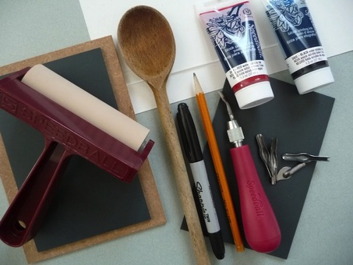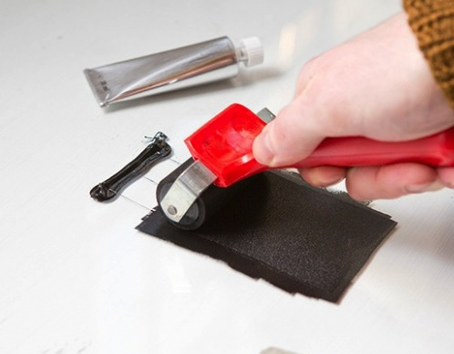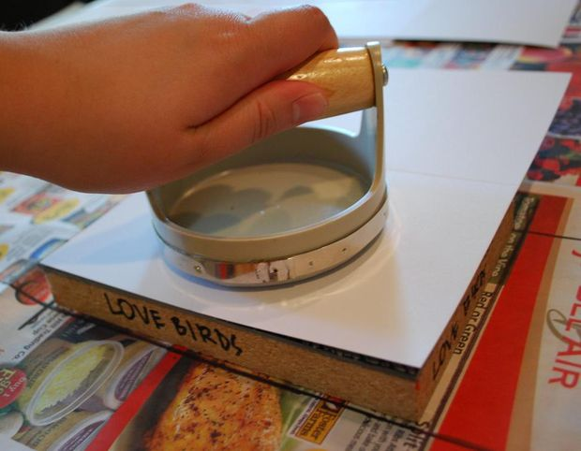

**Name:________________________**

8

## Print your image here!

How to Relief Print: Making a Linocut

[Date]

Iliana Ortiz

**Tools**

**One sheet of linoleum**

**Linoleum cutting tool with assorted blades**

**One piece of glass/ Plexiglas (for palette)**

**One brayer**

**Ink**

**Paper**

**Dark Marker**

**Pencil**

**Your idea**

**Barren**

**\*In case of cuts occurring it is a good idea to have **Band-Aids!****

****\*I will have the cleaning supplies****

7

## Create a drawing here!

Use this blank page to make an initial sketch of something you might want to print.

2

### Step 8:

Clean up! Make sure your tools and work area are clean. Put supplies back where they belong neatly.

Remove your paper slowly, and TA-DA! You have created your first print.

Transfer your drawing to you’re your linoleum. What you draw on your linoleum it will print out backwards. You can draw before on a piece of tracing paper if you wish. Draw on your linoleum in pencil first then go over you’re your sharpie.

### Step 2:

### Step 1:

Create your drawing. It can be anything. It is hard to have fine detail but it is possible to do so.

## Drawing and carving

## PRACTICE MAKES PERFECT

Your first print will probably not be perfect, but practice makes perfect. The more prints you make the better they will look!

### Step 7:

6

3

Get you piece of glass and place your ink on it. Work it until its soft. Grab your brayer and start rolling your ink until your brayer has a nice even color.

### Step 4:

## Ink

Start carving your image. When carving you linoleum, ALWAYS CARVE AWAY FROM YOU! Be aware that you are carving the area that will have no ink. Be patient depending on the size of your linoleum it can take a while.

### Step 3:

Take your paper and place it over the linocut. Get a barren and start applying pressure to your paper. Make sure to do it all over so there will not be any light spots.

### Step 6:

Start rolling your brayer evenly on your linoleum. Add a good amount of ink on it and to get a nice flat color on your print. Don’t be afraid in adding ink. Don’t take so long inking the ink can dry.

### Step 5:

## Start Printing!!

4

5